AdminUpdateProfile \*

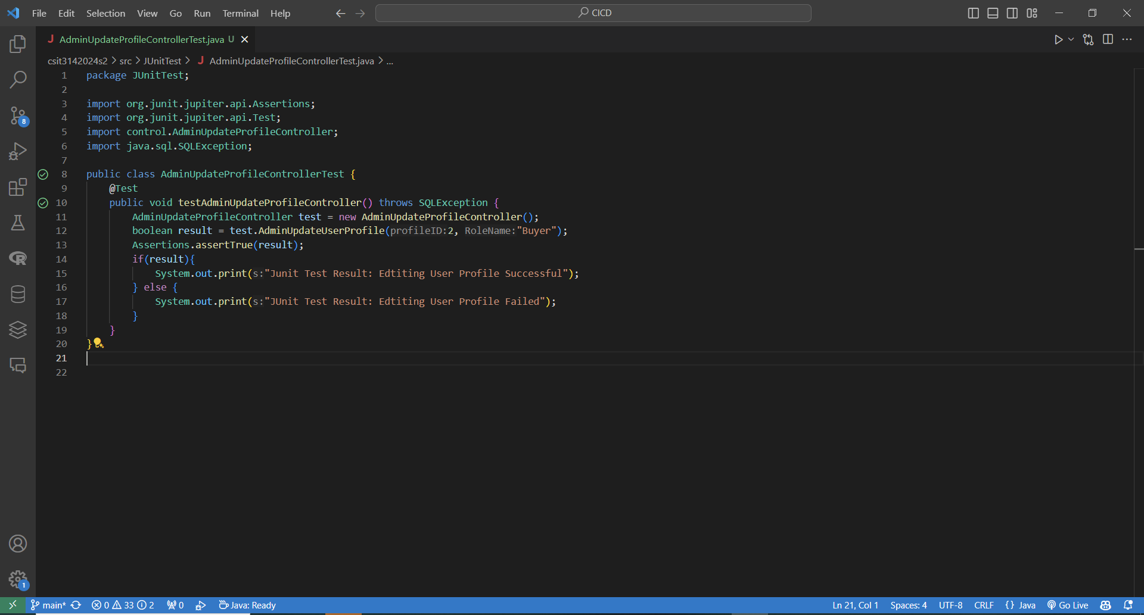

Test Result:

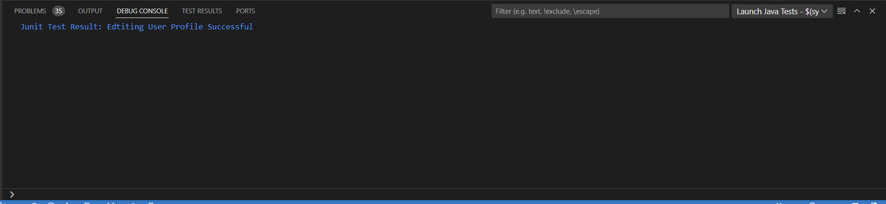

Testing code for Admin create New Account \*

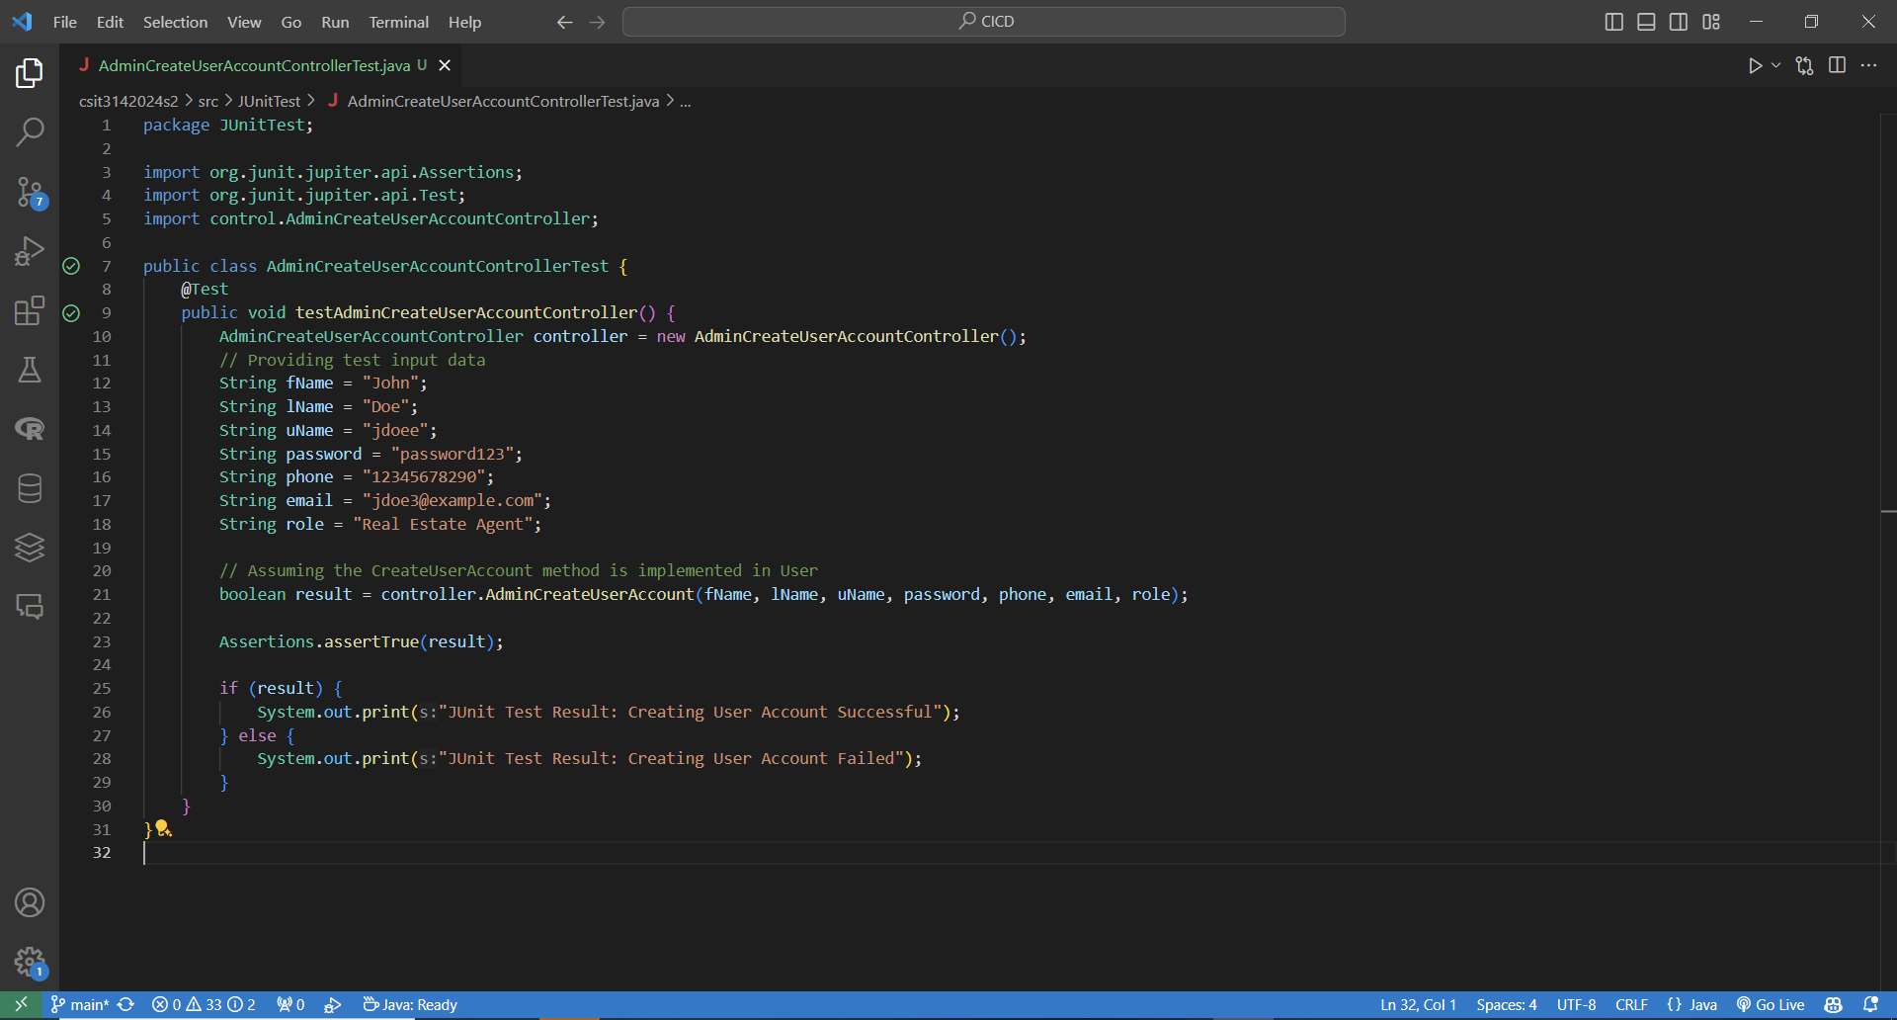  
Test Result:

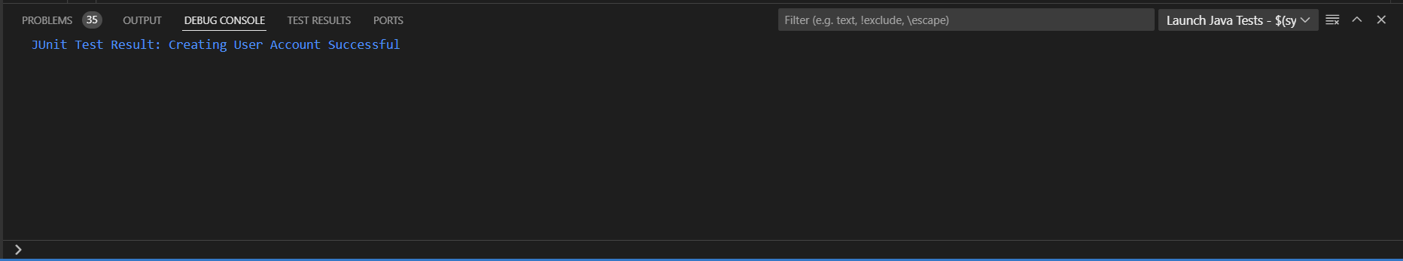

Admin view profiles \*

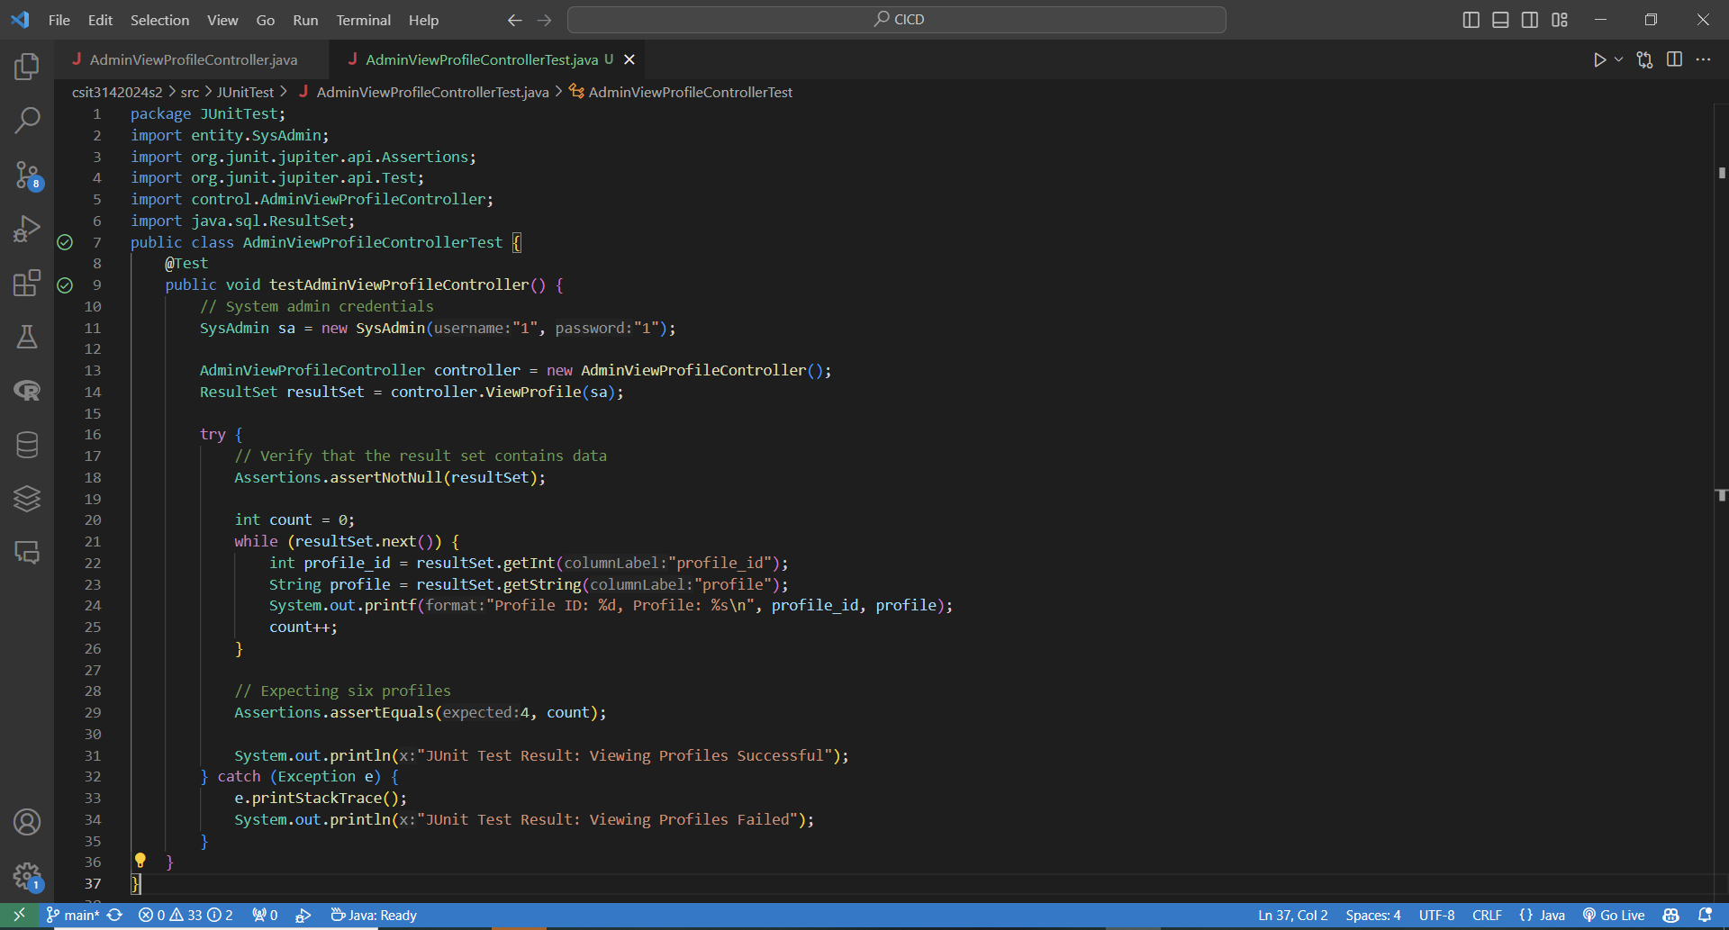

Result:

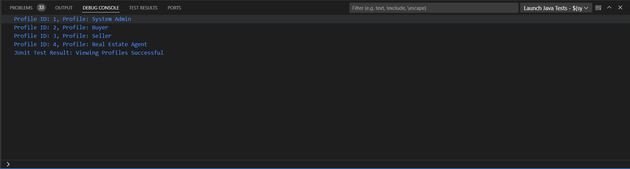

AdminSearchUserProfile \*

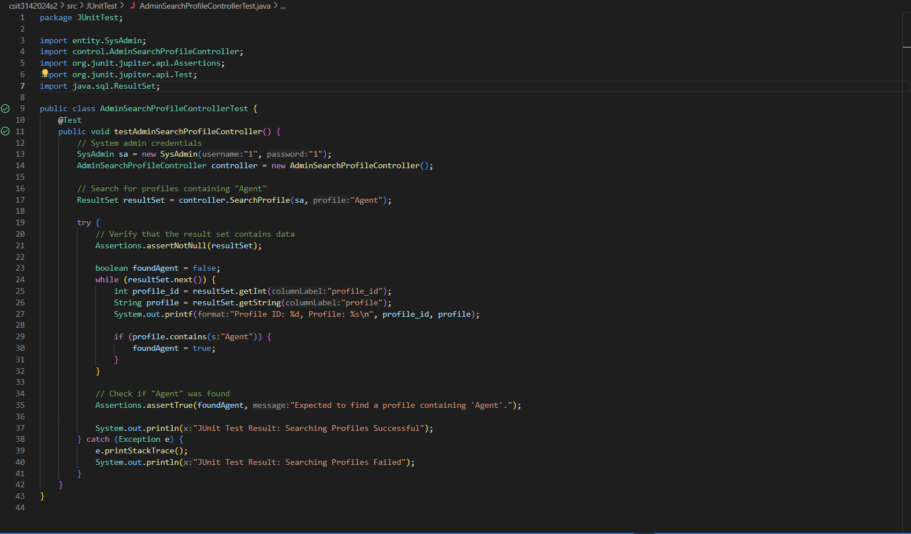

test result

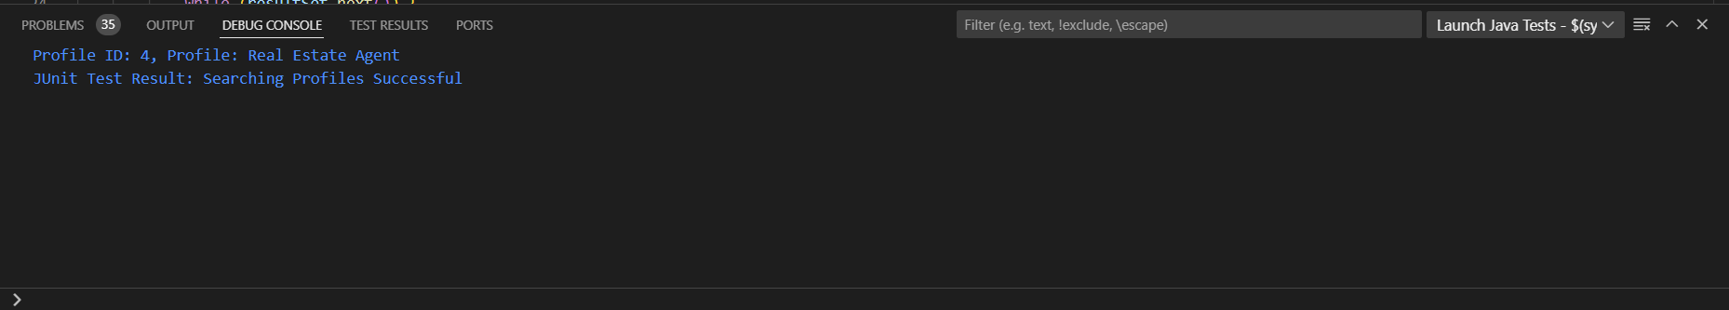

AdminCreateProfile \*

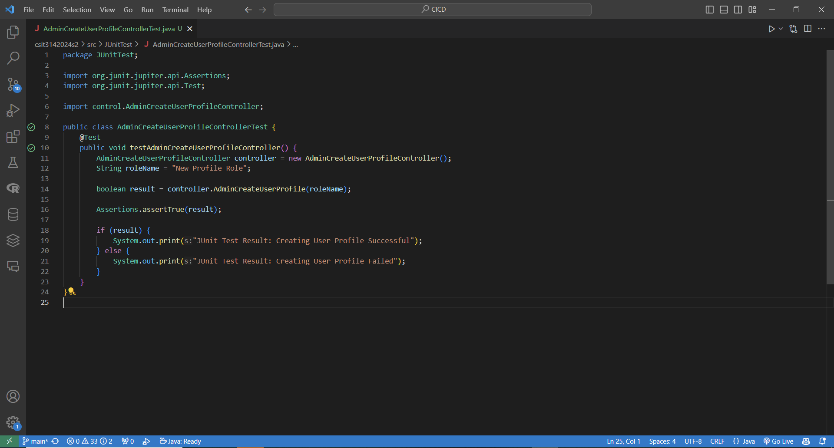

result:

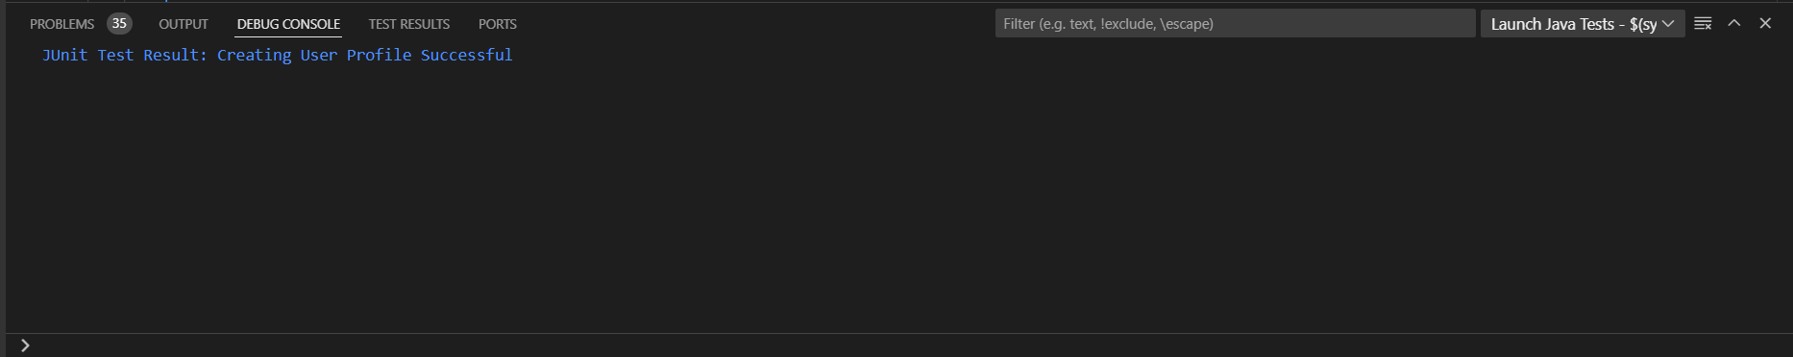

User Update Own Account \*

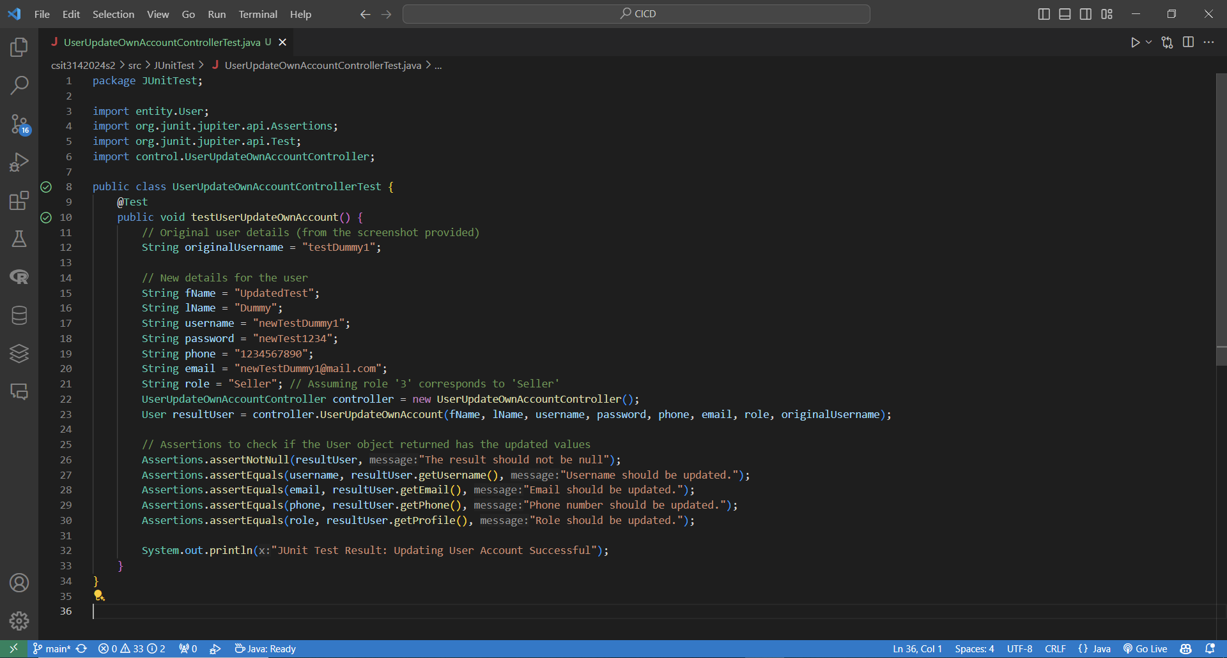

result

